ANNUAL DEGREE PROGRAM ASSESSMENT REPORT

Overview
The emphasis of the report should be on PLO and CASLO assessment, action items emerging from those assessments, and a table listing the top three budget requests from each degree program. Bullet points are certainly acceptable for the sections requiring written responses. Finally, if you respond to the system data please keep each section (demand, effectiveness and efficiency) to 100 words or fewer. Refer to the ARPD Instructions when you upload your report elements to the system website. The roman numerals indicate the corresponding system item number for when you upload your report to the UH System website.
http://www.hawaii.edu/offices/cc/arpd/instructional.php?year=2015&action=quantitativeindicators&college=HAW
Select Maui College and your program in the drop down menus.
On the page that shows the Quantitative indicators, click on “web submission”. You will log in to get to your program submission pages.

Remember to click on “save” icon for EACH SECTION.

See the end of this document for more assistance with web submission.

2014-15 Program Review preparation guidelines
Program Name: Agriculture and Natural Resources
ANALYSIS TAB
II. Analysis of the Program
- Briefly respond in 100 words or less for each cautionary and/or unhealthy Quantitative Indicator:
  - Demand Indicator: Unhealthy
The CIP 01.0606 Plant Nursery Operations and Management category selected for this data is very narrow and excludes many of the new and replacement positions for which program majors and graduates can qualify. This category excludes landscape maintenance, farmers, farm management, Seed companies, retail businesses and resource management agencies that often hire our majors. In addition entrepreneurial opportunities in landscaping and crop production are not included.

  - Efficiency Indicator: Healthy

  - Effectiveness Indicator: Healthy

- Any new significant program actions (new certificates, stopout, gain or loss of positions) as results of last year’s action plan.
Proposed curriculum changes are in progress and currently waiting for Kuali system to start process. Changes to include pre-requisites for AG 250 and changes to course sequencing. Changes to be in place by Spring 2017.

- If relevant, share a brief analysis for any Perkins Core Indicator not met.
1P1: Although the goal of 91.00 was not met, the actual was 84.62 which is reasonably close.
III. Action Plan
- Action Plan

  - PLO
PLO #1: Continue to work on the financial budgets. Have students start by creating a planting schedule or landscape maintenance schedule on a calendar. Use a single crop as classroom group exercise to go from planting schedule, sales forecast, cost of production, cash flow statement, income statement and then a balance sheet to illustrate how to develop the various budgets. Continue to use peer reviews to help students with feedback and to encourage students to meet deadlines. AG 230 will be taught Spring 2016 and these suggestions will be implemented.
PLO #4: Several curriculum changes need to be made. First need to change to name of the course to Landscape Design and Maintenance so that it reflects the actual course. Current name is the same as a similar course at UH Manoa.Second, reinstitute a prerequisite of AG 269 or AG 265 so students have more background. Doing a class project early in the semester - having one designed ahead of time - would help them with interpretation of scale plan to site. Also schedule semester after the prerequisite.
PLO#3: Provide students with example scenarios in the final weeks and go through standard control recommendations with them in our pest classes so they “get” the whole picture. AG 253 was a new class so more comparison of past and present throughout the course will help.
  - Program improvement
Curriculum changes are planned to improve student learning by developing materials for flipped type of instruction. More cooperative course offerings using hybrid delivery between Maui and Molokai is being investigated. Faculty need training in using various tools for these types of delivery.
Facility maintenance is a continuing challenge. Current personnel cannot cover the workload needed to maintain all areas to desired standard. Student help funds are limited currently to grant funds. Student help funds would assist but supervision also takes time and effort with turnover and student schedules. Summer 2015 grant funds were used to hire part time help to clean field area. Two windbreaks were started or improved. Fences were cleaned. Organize and create better storage spaces are ongoing. An open shed is needed to protect tractor implements. Grant funds may be able to assist but some help from O&M may be required. The greenhouse needs to be re-braced as a major brace in the back has rusted through. In addition spring 2015 brought two major storms that blew off portions of the greenhouse roof and siding. O&M is aware of this but no progress has been made to correct the broken facility. Looks bad and is a safety issue.
Faculty limitations. One faculty at Kahului campus can only teach so many courses.Courses are usually limited to every other year offering. This limits the ability to offer enough courses for students to graduate in a timely manner. Lecturers can be difficult to find for the various specialized courses which all have lab preparation.
IV. Resource Implications: (COPY AND PASTE BUDGET HERE)
List of top three resource requests (IV):

Budget request | Amount | In 100 words or less describe how does this request relate to the strategic plan | If outside of the Strategic Plan provide rational for the request (in 100 words or less).
AG&NR Faculty | 56,084 | Quality of Learning Objective 2: High quality degree and courses to meet needs requires additional faculty expertise. Student Success Objective 1: Faculty needed to offer courses in timely manner so students can progress through college. | Meet WASC recommendation for minimum 2 faculty programs.
Student Help Funds | $6000 | Quality of Learning Objective 3: Physical support for high quality teaching and learning – student help to maintain and improve quality of field, greenhouse and lab to help meet course learning objectives.
Supply Funds | $3,000 | Quality of Learning Objective 3: Physical support for high quality teaching and learning – purchase tools and consumables to carry out lab activities to meet SLO’s

DESCRIPTION TAB
Provide a brief description of your program and program mission:
We envision a program that promotes active student engagement by providing high quality instruction in agriculture, horticulture, and natural resources with an emphasis on entrepreneurship and sustainability.
P-SLOs TAB
- PLO selected for assessment (click on the PLO assessed – it will turn green).

- Industry Validation (check all that apply):

Advisory Committee Meeting(s) __, How many? __
Did Advisory Committee discuss CASLO/PLO? Yes__ No__
Coop Ed Placements _X_ Fund raising activities/events _X_ Service Learning __
Provide program services that support campus and/or community _X_(250
Outreach to public schools _X_(such as October 2014 pumpkin patch-250 kids K-5)
Partner with other colleges, states and/or countries _X_(Consortium grant with all other CCs)
Partner with businesses and organizations _X_(such as Maui Nui Botanical Garden, Maui Association of Landscape Professionals)
Other__ Describe_______________________________________________________________

- Expected level of Achievement:
For the PLO assessed, _80_ % of students completing the assignment/course expected to meet expectations for the assignment/course.
- Courses (or assignments) Assessed:
PLO #3
AG 253 Hawaiian Foods Plants
AG 281 Weed Science

- Assessment strategy/Instrument/Evidence (check all that apply):
Work Sample__ Portfolio__ Project __ Exam _x_ Writing Sample x__
Other__ Please explain_Essays within Final exam___________

- Results of program assessment:
  - The following were present at the PLO assessment:
Course | Instrument | Acceptable or better | Below
AG 253 | Essay 1: Cultural – farmers today vs. pre-contact farmer | 8/12 – 67% | 4/12 – 33%
AG 281 | Essay 1: Organic farm weed control | 11/17 – 65% | 6/17 – 35%
AG 281 | Essay 2: Forest environment weed control | 15/17 – 88% | 2/17 – 12%

  - Strengths and weaknesses (best practices and educational gaps) found from PLO assessment analysis .
AG 253: Some students did not answer the essay. Some students were too brief in their answers. More work needed on answering essay questions. Additional forms of assessment may be needed to give a better picture. Class had an emphasis on hands-on work as well.
AG 281: First essay some students missed seeing “organic” in the scenario presented in the essay and so made recommendations that were not acceptable so this caused some poorly scored essays. Overall most students had a good understanding and could recommend basic standard control measures.
- Other comments:
Describe CASLO assessment findings and resulting action plans. Go to Laulima UHMC CASLO Assessment for your program’s “Assessment results” and summarize below.

CASLO assessment findings | Action plan to address findings
Math skills demonstrated were not relevant to the field (see report attached) | Curriculum change to curriculum Spring 2016 for enrollment Fall 2017: Embed 100-level math skills into AG 235 Irrigation

- Next steps:
For program learning outcomes (check all that apply):
Assess the next PLO__X_ Review PLOs___ Adjust assignment used for PLO___
Adjust course used for PLO___ Meet with Advisory Committee____
Other___ Please explain:

System website:
http://www.hawaii.edu/offices/cc/arpd/instructional.php?year=2015&action=quantitativeindicators&college=HAW
Select Maui College and your program in the drop down menus.
On the page that shows the Quantitative indicators, click on “web submission”.
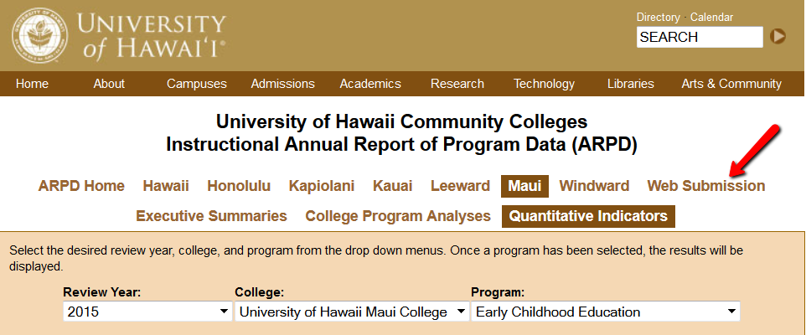

You’ll log in on the next page.
When the page with tabs comes up, click on Analysis tab.


Click on “edit”. Copy and paste from this document into each section. If you are pasting from Word, you need to click on the “W” icon and then paste into the box that pops up (like in Laulima). See green arrow below.
REMEMBER TO “SAVE” EACH SECTION! (red arrow in pic below).

You’ll be entering information into:
- Analysis
- Description
- P-SLOs
- External (if your program has an external exam)

REMEMBER TO SAVE (red arrow) EACH SECTION!


